**Troubleshooting Email Relay at SCS**

Email relay servers:

LBC-EXC01 (10.1.2.106) - Full exchange 2010

LBC-SYN01 (10.1.2.105) - IIS smtp service



**Troubleshooting relay for RMC and Snmp emails (scsrmcmonitor, snmpc)**

* Check LBC-SYN01\smtp windows service is running.
* Check LBC-SYN01\IIS 6.0 Manager\SMTP Virtual Server is running.
* Check SMTP log for error. Path: C:\Windows\System32\LogFiles\SMTPSVC1

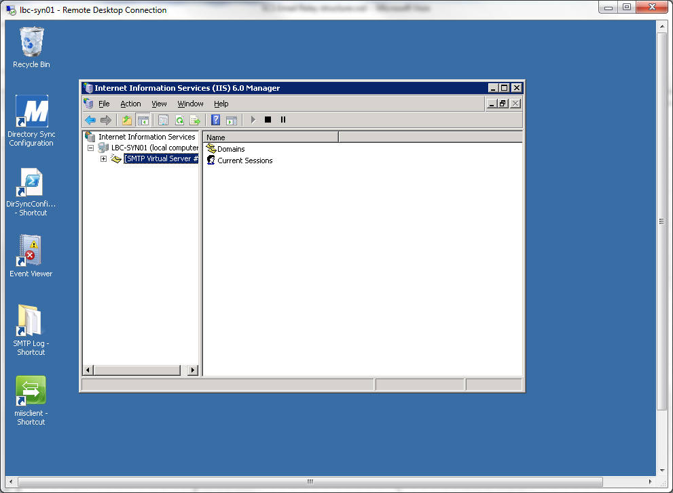

* Check Office 365 Service health at Office 365 admin portal.

**Troubleshooting relay for all others ( Deltek, Scanner, SolarWind etc. )**

* Open Exchange Management Console at LBC-EXC01
* Check Receive Connector status ‘Enabled’

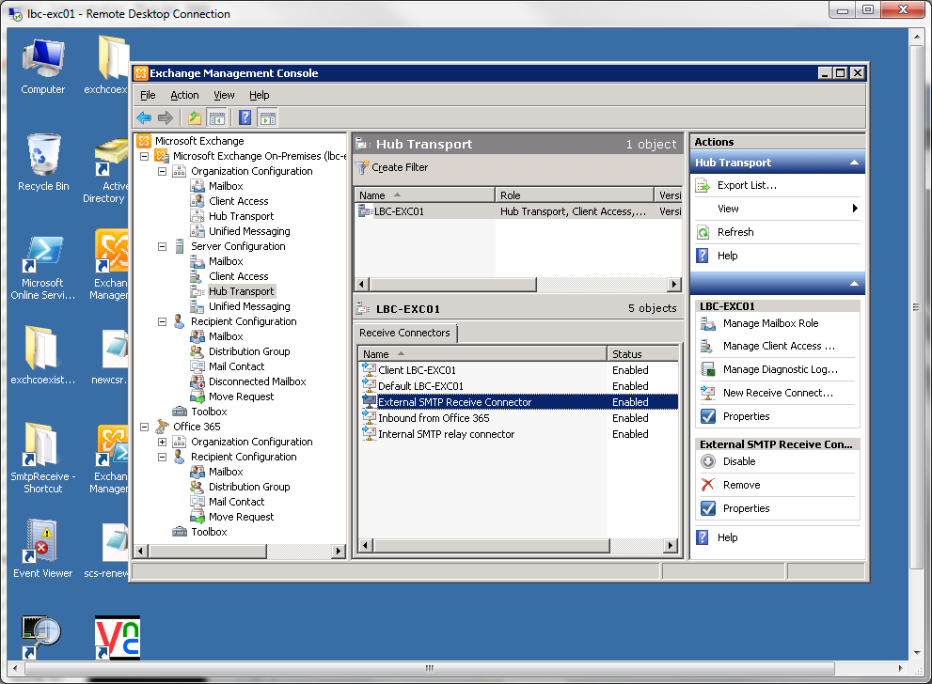

* Check Send Connector status ‘Enabled’

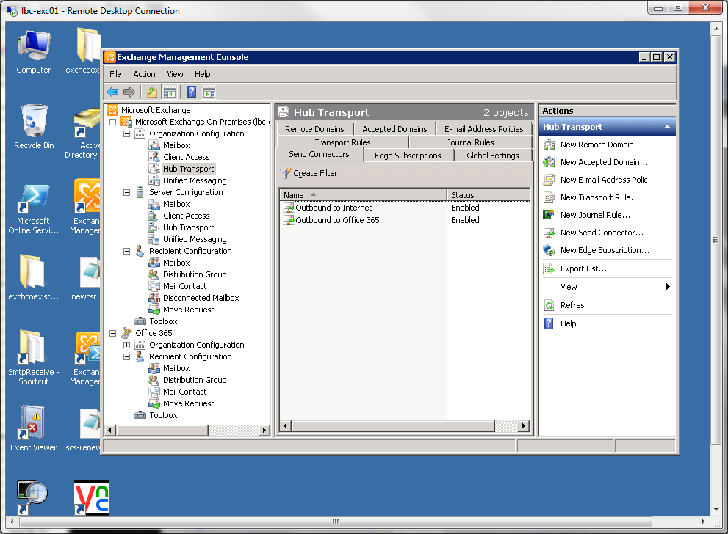

* Check Microsoft Exchange Transport windows service is running.

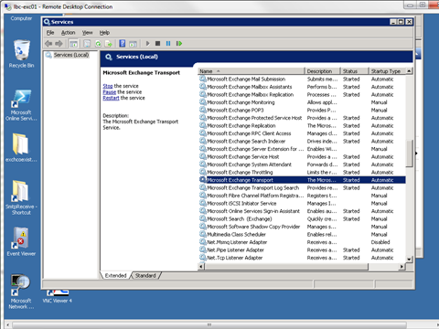

* Check SMTP log for error.

Receive Log:

C:\Program Files\Microsoft\ExchangeServer\V14\TransportRoles\Logs\ProtocolLog\SmtpReceive

Sender Log:

C:\Program Files\Microsoft\Exchange Server\V14\TransportRoles\Logs\ProtocolLog\SmtpSend

* Check Office Service health at Office 365 admin portal.